How is the body organized?  What is a cell?  What is the structure of cells?  What are the functions of cells?  What are tissues?  What are the different types of tissue?  What is an organ?  What are the different organ systems?  What is homeostasis? | The human body is organized into systems made of organs made of tissues made of cells.  A cell is the basic unit of structure and function in a living thing.  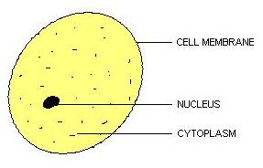  Cells carry on processes that keep organisms alive (growth, reproduction, waste, etc.)  A tissue is a group of similar cells that perform the same function.  1. Muscle (movement)  2. Nervous (electrical messages)  3. Connective (support)  4. Epithelial (skin)  An organ is a collection of specific tissues that perform a job (heart, stomach, liver, lung, etc.)  1. Circulatory/cardiovascular  2. Skeletal  3. Digestive  4. Nervous  5. Endocrine  6. Respiratory  7. Muscular  8. Excretory  9. Reproductive  Homeostasis is the process by which an organism’s internal environment remains stable/balanced in spite of changes in environment.
Summary:

